**ANALYZING THE PERFORMANCE & EFFICIENCY OF RADISSON HOTELS USING DATA VISUALIZATION TECHNIQUE**

**INTRODUCTION**

* 1. **Overview**

Multiple five star hotels are owned by Radisson. Radisson Hotels are in the hospitality industry for the past 100 years. Due to strategic moves from other competitors and ineffective decision-making in management, Radisson is losing its market share and revenue in the luxury/business hotels category.

* 1. **Purpose**

To create an analytical dashboard and story for providing the insight for making better business decisions.

**PROBLEM DEFINITION & DESIGN THINKING**

**2.1 Empathy Map**

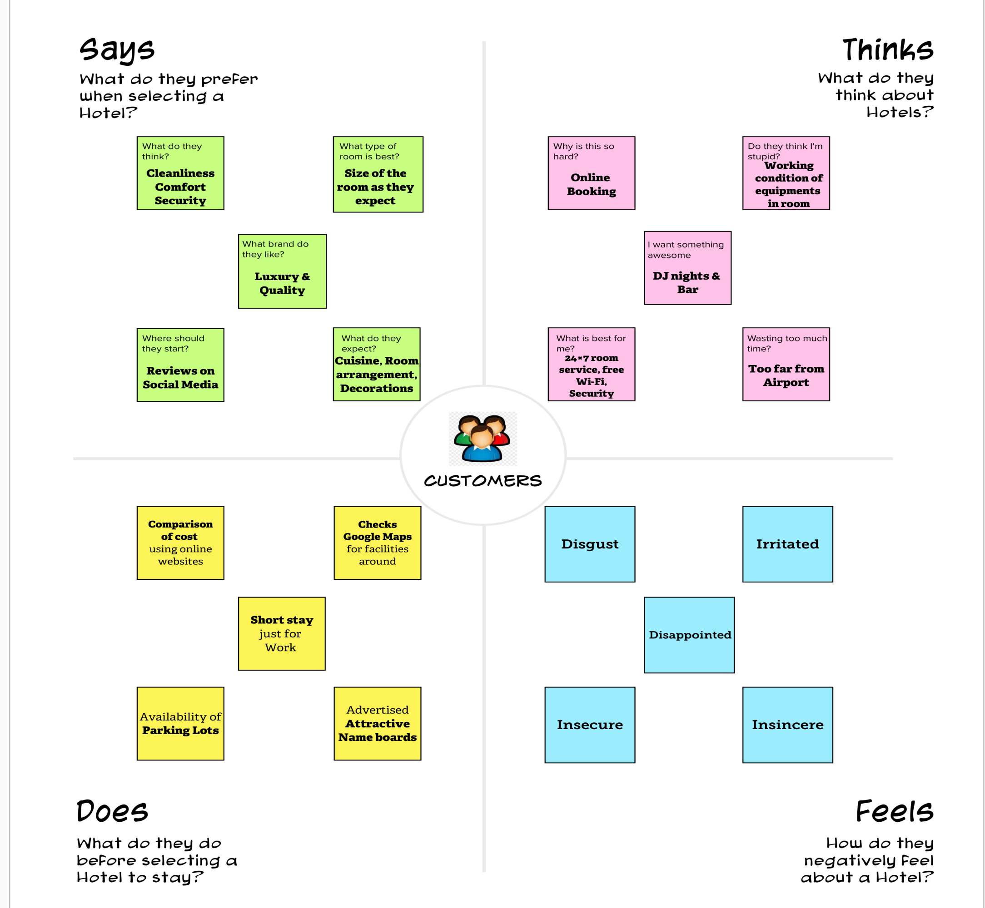

**2.2 Ideation & Brainstorming Map**

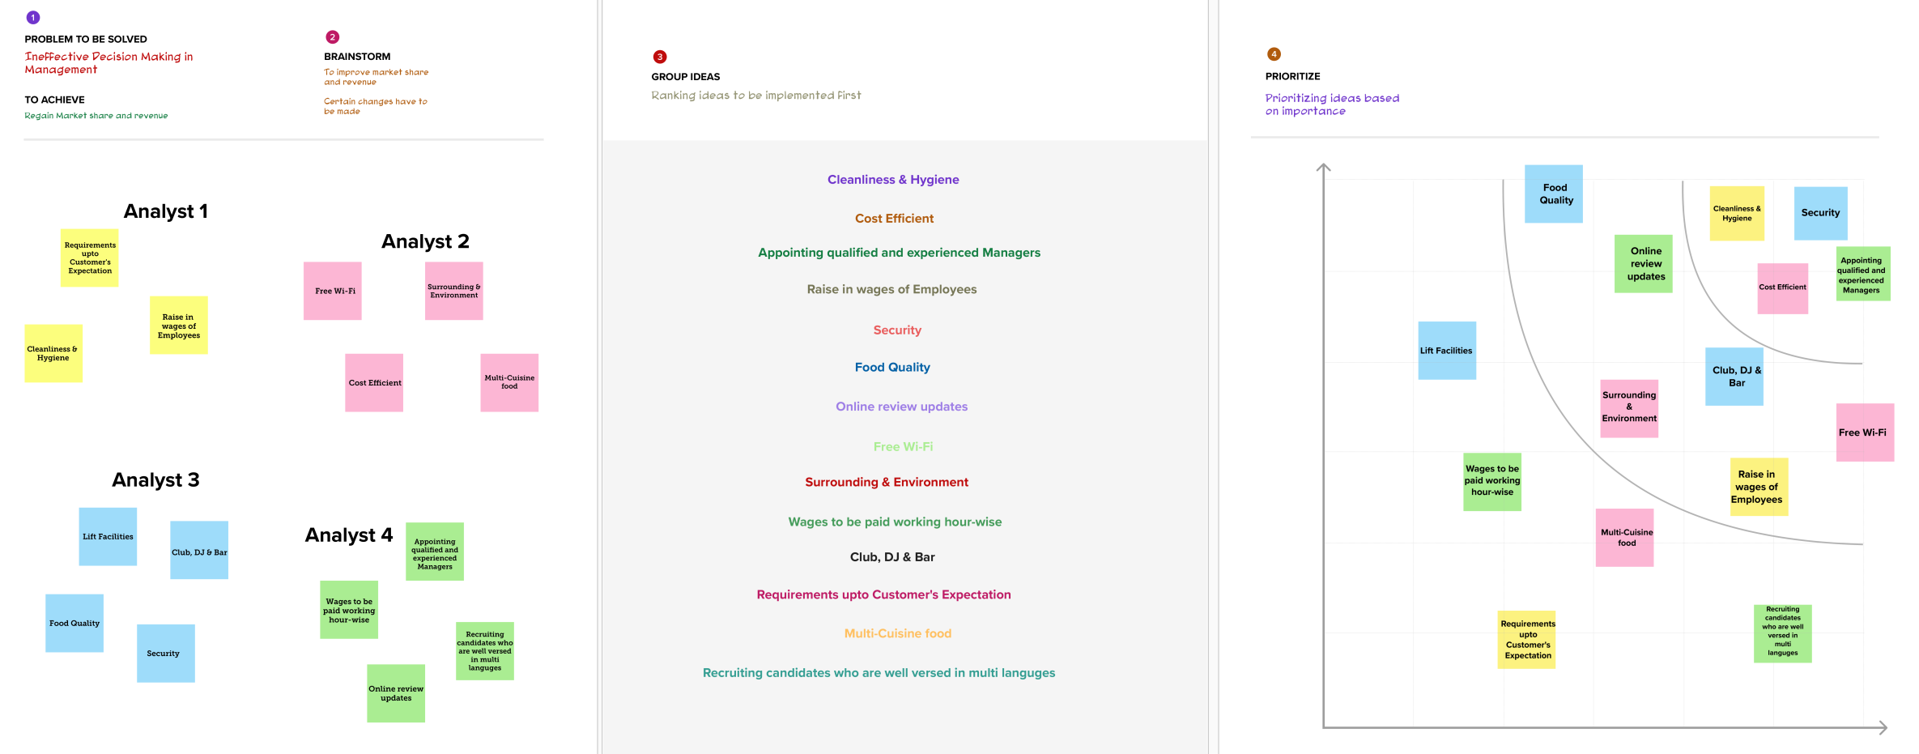

**RESULT**

1. **Story**

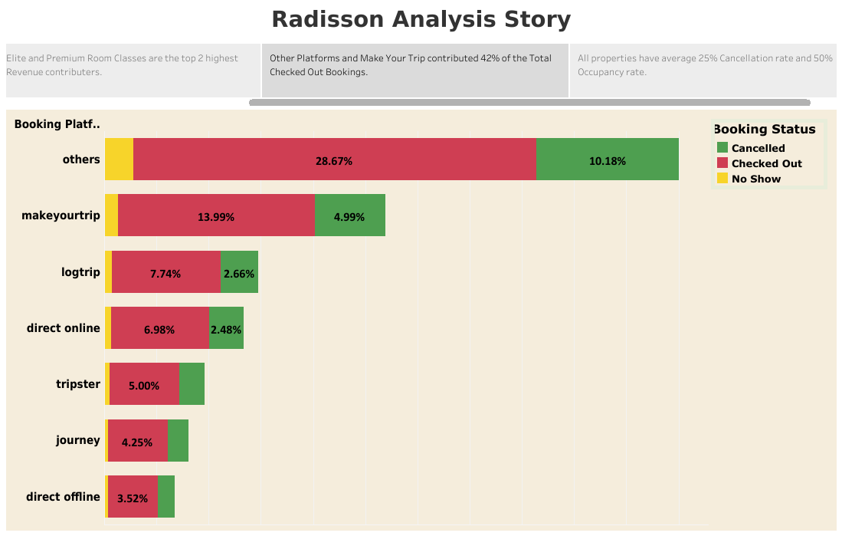

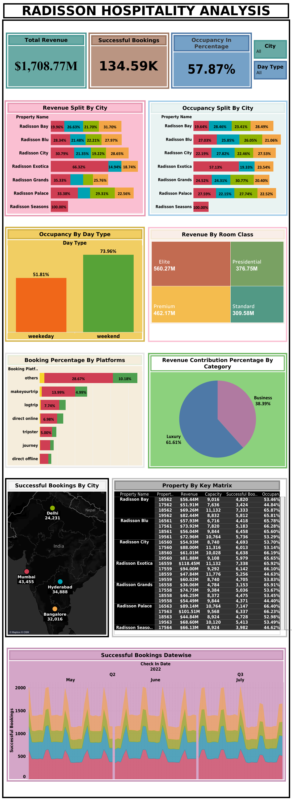

1. **Dashboard**
2. **Web Application**

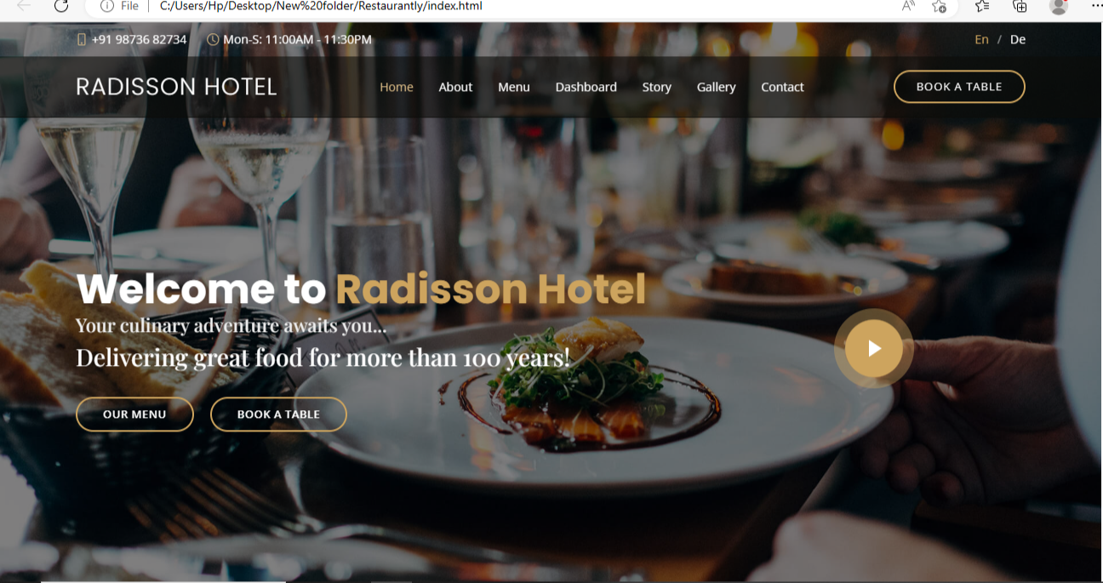

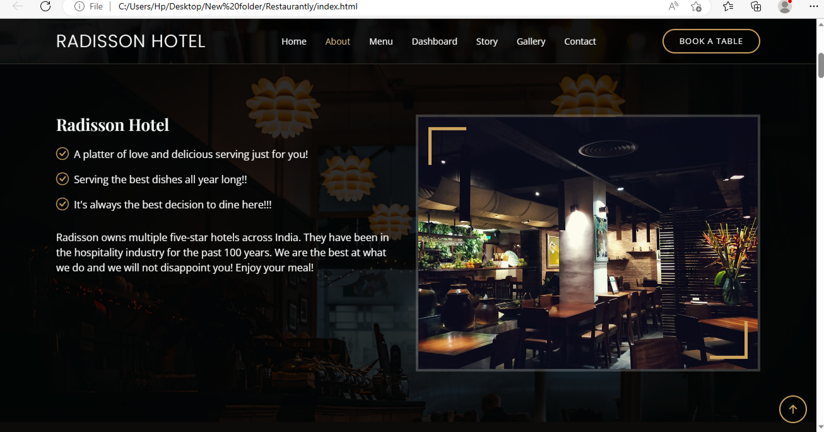

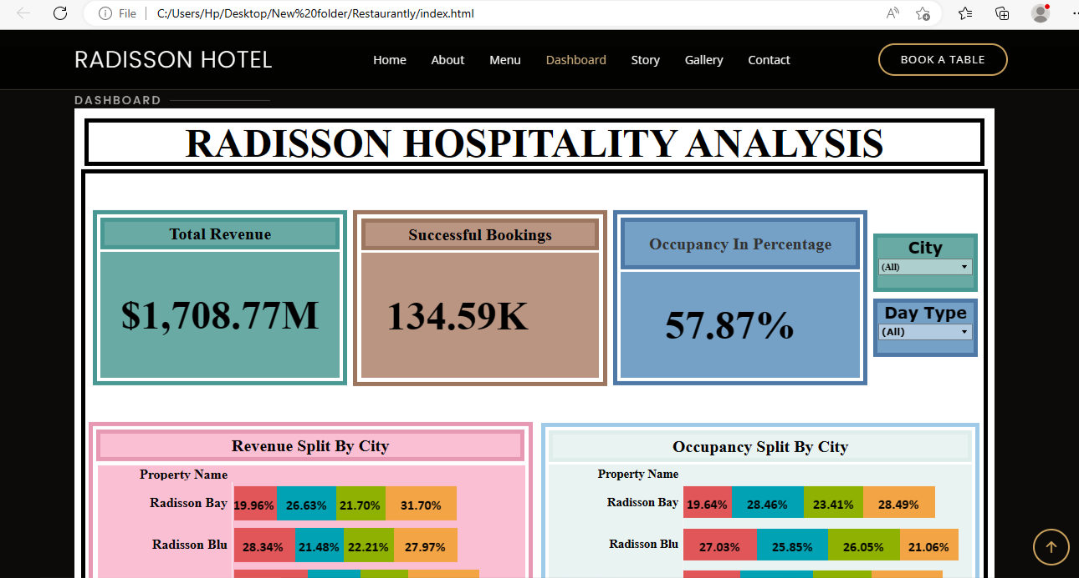

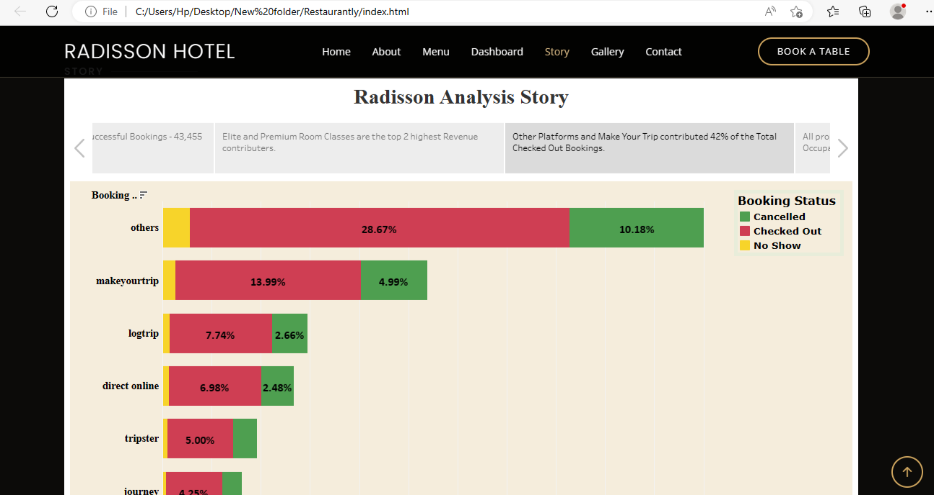

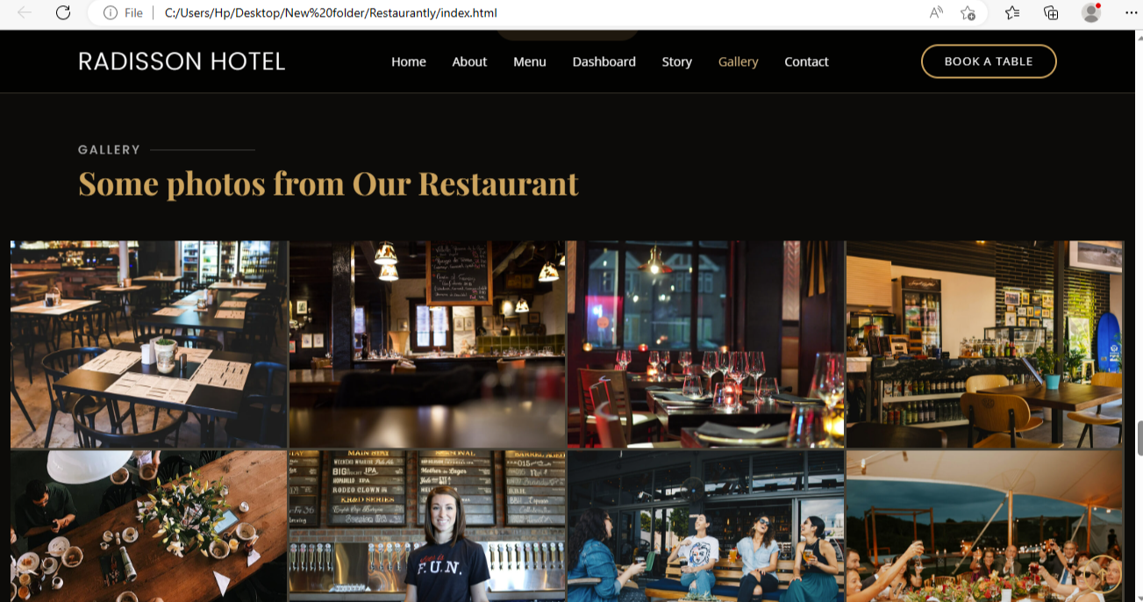

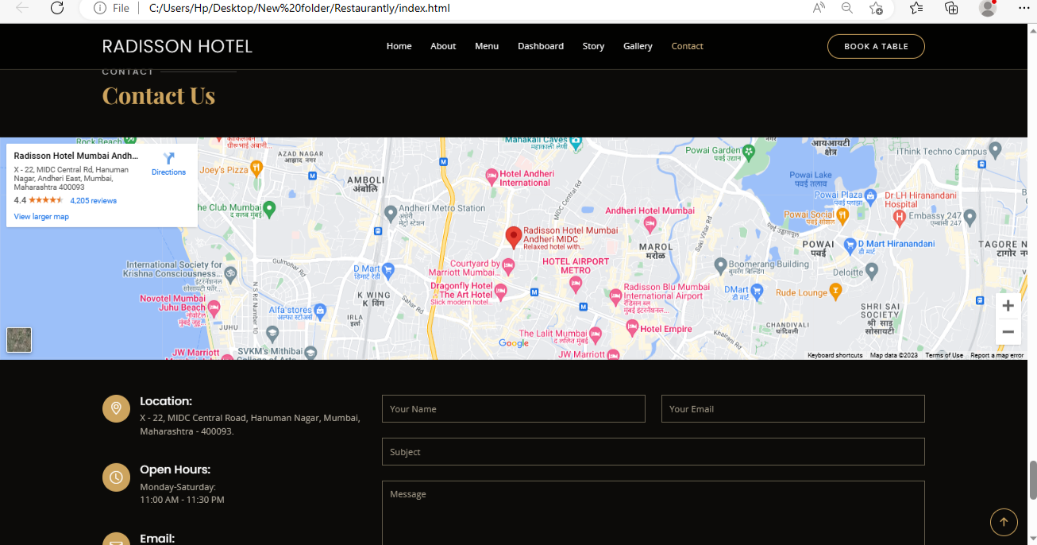

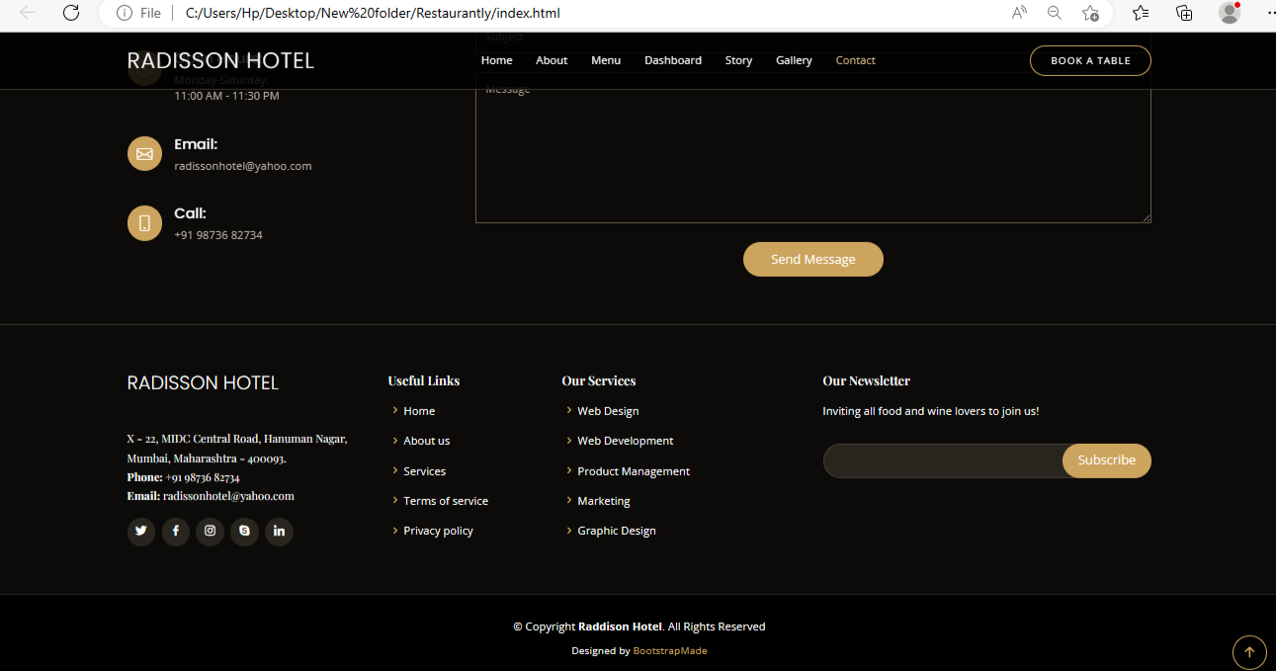

**ADVANTAGES OF THE PROPOSED SOLUTION**

* By the Data Analytics using Tableau we have created many insights on how to increase the market share value of Radisson Hotels.
* Cities and areas in which the Hotels have to be improved were found out.
* Properties like Occupancy, Bookings, Room Class which needs an upgrade is also found.

**APPLICATIONS**

* Mumbai counts for the highest Successful Bookings.
* Platforms with fewer Bookings can be increased using Booking discounts.
* Occupancy rate should be increased and Cancelled Bookings % should be decreased.
* Mumbai branch contributes for more Revenue and Occupancy.
* Occupancy is higher during weekends.
* Luxury Class contributes for more Revenue.

**CONCLUSION**

* By using Data Analytics by Tableau we have found out the Revenue Split by City, Occupancy Split by City, Occupancy by Day Type, Revenue by Room Class, Booking Percentage by Platforms, Revenue Contribution Percentage by Category, Successful Bookings by City, Property by Key Matrix and Successful Bookings Datewise are found.
* We have concluded that the Total Revenue is counted as $1,708.22M, Successful Bookings as 134.59K and Occupancy in Percentage as 57.87%.

**FUTURE SCOPE**

* To improve sales and profitability we have to refine our pricing plan in the cities which does not perform well, that is, by reducing the product prices.
* By concentrating more on the regular customers and also on new customers, sales can be increased.
* By actively doing Content marketing, Email marketing, Social media marketing and Search Engine marketing we can enhance our revenue.

**APPENDIX**

1. **Source Code**

[**..\..\index.html**](../../index.html)